1.10 Sequence of Transformations, Mapping Images, & Rotational Symmetry Geometry

Directions: Complete each sequence of transformations.

1) Translate 3 units right & 5 units up. 2) Rotate 180ᴼ CCW about (–2, –1). 3) Shrink horizontally by ½.
Then, rotate 90ᴼCCW about the origin. Then, reflect over y = x. Then, reflect over y = 0.
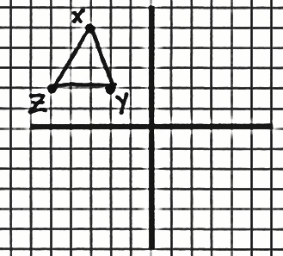
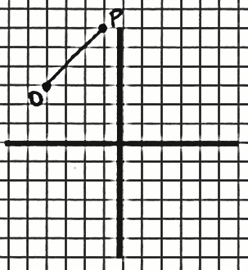
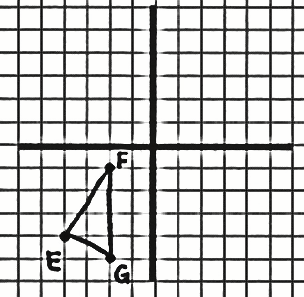

Directions: Find A’’ given the sequence of transformations.

4) A(4, –2); Reflect over y = –x; then, dilate by a scale factor of 2 with the origin as a center.

5) A(0, –3); Rotate 90ᴼ CW about the origin; then, horizontally stretch by 3.

6) A(–2, 2); Translate 6 units down; then, dilate by a scale factor of ½ with a center of (4, –1).

Directions: Use the rule for the sequence of transformations to find B’’.

7) (x, y) → ‘‘(x – 3, –y) when B(4, 5) 8) (x, y) → ‘‘(y, 4x) when B(–1, 6)

9) (x, y) → ‘‘(–4x, y) when B(–5, –1) 10) (x, y) → ‘‘(–3y, 3x) when B(0, 2)

Directions: Describe the sequence of transformations displayed in each rule.

11) (x, y) → ‘‘(x – 3, –y) 12) (x, y) → ‘‘(y, 4x)

13) (x, y) → ‘‘(–4x, y) 14) (x, y) → ‘‘(–3y, 3x)

Directions: Describe how each pre-image can be mapped onto the image using ONE transformation.
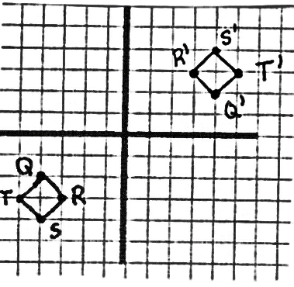
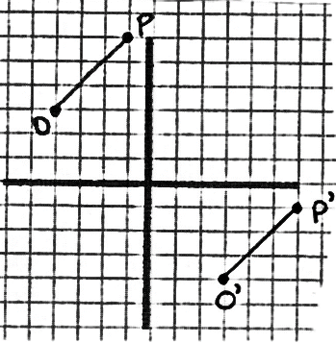
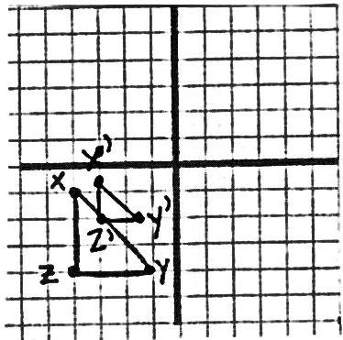
15) 16) 17)

Directions: Describe how each pre-image can be mapped onto the image using TWO transformations.
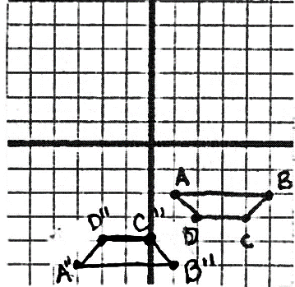
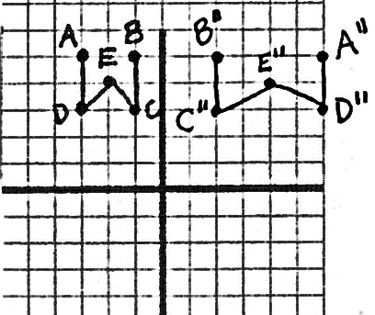
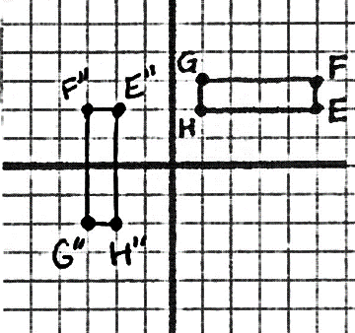
18) 19) 20)

Directions: Describe how each pre-image can be mapped onto itself using the specified number of transformations.
21) A(3, 5) & B(2, 1); 22) A(3, 5) & B(2, 1);
2 transformations involving 2 dilations 3 transformations using a rotation & 2 reflections

Directions: Circle each of the angle measures that would map the image onto itself through a rotation around the fixed point. Each polygon is a regular polygon.
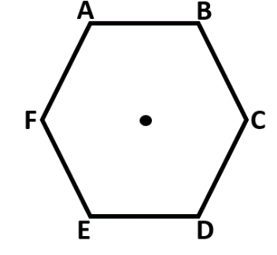
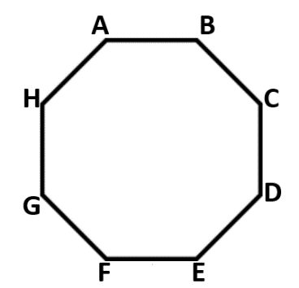
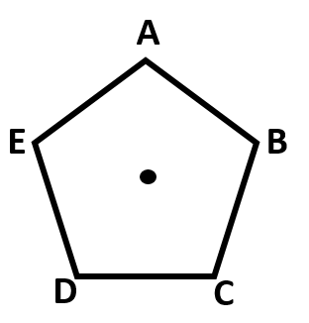
23) 24) 25)

36ᴼ 72ᴼ 90ᴼ 144ᴼ 90ᴼ 120ᴼ 180ᴼ 240ᴼ 45ᴼ 90ᴼ 120ᴼ 585ᴼ

