1.11 Unit 1 Test Review Geometry

Directions: Using the rule provided, describe the transformation or sequence of transformations that have occurred.

1) (x, y) → ‘‘(y, x + 2) 2) (x, y) → ‘(–y, –x) 3) (x, y) → ‘‘(–x, 3y) 4) (x, y) → ‘(–y, x)

Directions: Write the rule to represent the transformation.

5) Rotate 180ᴼ CW about the origin 6) Horizontal stretch of 10

7) Translate 4 units left and 8 units up 8) Reflect over y = x

9) Rotate 270ᴼ CCW about the origin 10) Dilate by a scale factor of $\frac{1}{3}$

Directions: Graph the transformation using the given information.

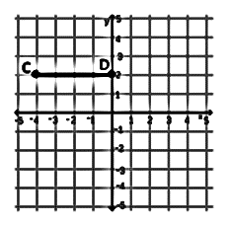
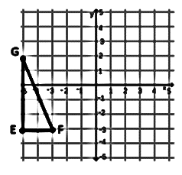
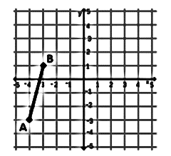
11) (x, y) → (x, 1.5y) 12) Dilate by $\frac{1}{2}$; then, reflect over x = 1 13) Rotate 180ᴼ CW about (–1, 0)

Directions: Solve each problem.

14) If Z(3, –4), what is Z’’ after it has been rotate 180ᴼ CW and then vertically stretched by 5?

15) If R’(0, 5), what is R if the following rule was used to produce the image: (x, y) → ‘(–y, –x)?

16) If J(3, 1) is reflected over y = x, dilated by 3 with a center at (1, 2), and then rotated 90ᴼCCW, what is J’’’?

Directions: Describe the sequence of transformations.

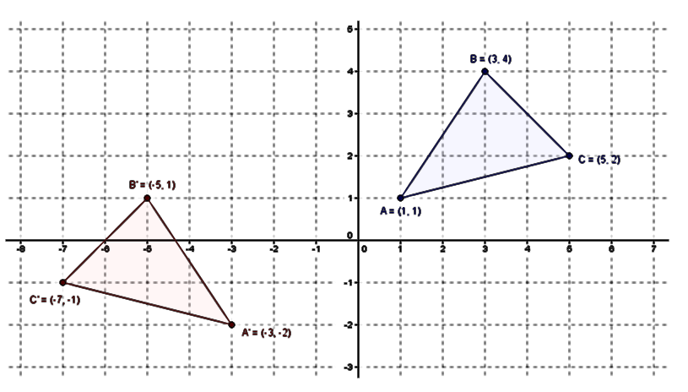
17)

Directions: Determine how to map the pre-image onto the image.

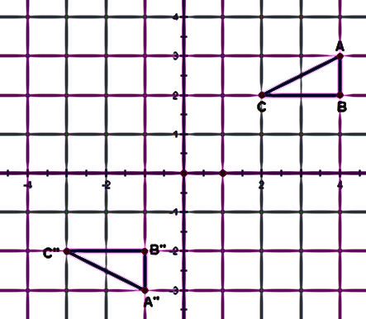
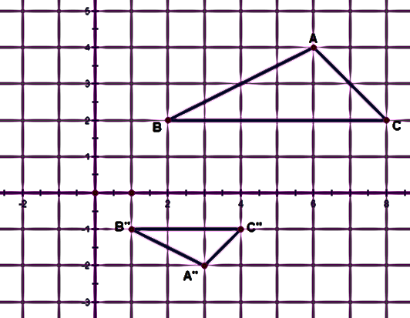
18) 19)

Directions: Determine how to map the pre-image onto itself using the given number of transformations.
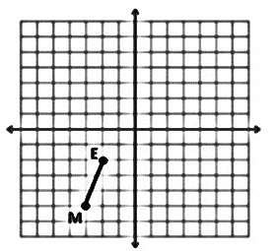
20) 1 transformation

21) 2 transformations

22) 3 transformations

