1.3 Homework - Reflections and Rules Name: __________________________

Directions: Write the rule of the reflection.

1) A line segment is reflected over the y-axis. 2) A triangle is reflected over the x-axis.

Directions: Describe the transformation. (This is a mixed review & includes sequences of transformations).

3) (x, y) → ‘(x, –y) 4) (x, y) → ‘(x + 2, y) 5) (x, y) → ‘(–x, y)

6) (x, y) → ‘(x – 4, y) *7) (x, y) → ‘‘(–x, y + 1) *8) (x, y) → ‘‘(x + 3, –y – 5)

Directions: Complete the transformation of the new image. If the rule was provided, describe the transformation. If the transformation was described, write the rule.

9) AB(x, y) → A’B’(x, –y) 10) CDE (x, y) → C’D’E’ (x, –y) 11) JK(x, y) → J’K’(–x, y – 1)
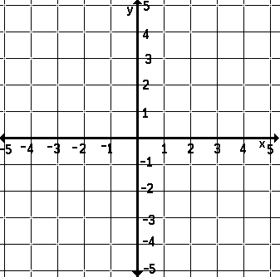
A
K
E
D
B

J
C

12) Reflect over y = 0. *13) Reflect over the x-axis. 14) Reflect over the y-axis.
Then, translate left 4 units.
G
A
M
E
E
M

T
A
B

Directions: Find the missing point using the given information.

15) If the result of (x, y) → ‘(x – 1, y + 2) is A’(–5, 2), 16) The pre-image (–3, –9) is reflected using the rule
what is the pre-image, or A? (x, y) → ‘(x, –y). What is the image coordinate?

17) If B(4, –2) is applied to (x, y) → ‘(–x, y), what 18) If the result of (x, y) → ‘(–x, y) is B’(–6, –1),
is the coordinate that represents the image? what is the pre-image, or B?

Directions: Solve each problem.

19) C(3, –2) and D(–1, 0) transforms to C’(–3, –2) and D’(1, 0). What transformation has occurred?

20) F(a, b) is reflected over the x-axis. If a < 0 an b > 0, in what quadrant with F’’ be located?

21) The function, y = –2^{x}, the passes through H(5, –32). If the graph is reflected over the y-axis, what are the coordinates of the image of H?

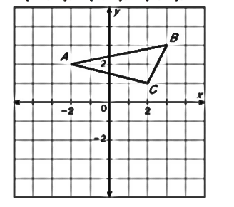
22) In the graph below, the pre-image is first reflected so that A’ is located
at (2, 2). The new image is then translated to A’’(2, –2). At what ordered
pair would B’’ be found following this same sequence of transformations?

