1.5 HW Rotations about the Origin Geometry

Directions: Write the rule of the transformation.

1) A triangle ABC is rotated 360 degrees CW. 2) A line segment DE is rotated 180 degrees.

3) A square MNOP is rotated 270 degrees CW. 4) A line segment XY is rotated 90 degrees CW.

Directions: Describe the transformation. (This is a mixed review).

5) (x, y) → ‘(–y, x) 6) (x, y) → ‘(y, –x) 7) (x, y) → ‘(–x, –y)

8) (x, y) → ‘(x + 2, y) 9) (x, y) → ‘(–y, –x) *10) (x, y) → ‘‘ (–y, x + 1)

Directions: Complete the transformation of the new image. If the rule was provide, describe the
transformation. If the transformation was described, write the rule.

11) AB(x, y) → A’B’(y, –x) 12) CDE (x, y) → C’D’E’ (-y , x) 13) JK(x, y) → J’K’(–x, –y)
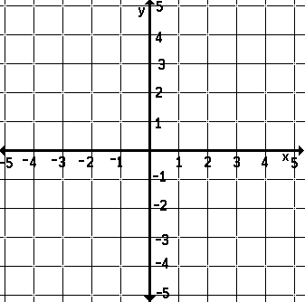
B
D

E

C
K
A

J

14) Rotate FGH by 270° CCW. 15) Rotate ABCD by 90° CCW. 16) Rotate ABC 180°

C
B

G

B

A
D

H
F

A
C

Directions: Find the missing point using the given information.

17) A(8, 4) 18) B’(–6, –1)
Rule: (x, y) → ‘(–x , –y) Description: Rotation of 270ᴼ CW.
Find A’. Find B.

19) C’(0, 4) 20) Pre-Image: (–2, 6)
Rule: (x, y) → ‘(y, –x) Description: Rotation of 90ᴼCCW.
Find C. Find the image coordinate.

21) Image: (5.4, 11.2) 22) Pre-Image $\left(-\frac{1}{3},-4\frac{5}{8}\right)$
Description: Rotation of 270ᴼCCW. Rule: (x, y) → ‘$\left(-y, x\right)$
Find the pre-image coordinate. Find the image coordinate.

Directions: Solve each problem.

23) A wheel has its center located at the origin of a graph. A nail is found on the bicycle wheel in a location of
W(–25, 3). After the tire is rotated 180ᴼCW, at what coordinate is this nail?

24) (–h, k) is rotated 90ᴼCCW. What is the coordinate of its image?

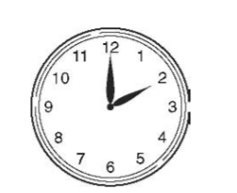

25) The long hand of this clock is rotated 270ᴼCW. What is the time after this rotation?

26) After a rotation about the origin, M(4, 12) has an image of M’(12, –4). What is R’ if R is located at (–1, 3) and follows this same rotation?

