1.8 HW Dilations with Origin Center Geometry

Directions: Write the rule of the transformation.

1) A segment AB is dilated by a scale factor of 5 2) A triangle DEF is dilated by a scale factor of $\frac{1}{4}$

3) A square MNOP is stretched horizontally by 4) A line segment JK is stretched vertically by
a scale factor of 1.25 a scale factor of 3

Directions: Describe the transformation. (This is a mixed review).

5) (x, y) → ‘(–y, –x) 6) (x, y) → ‘(5x, 5y) 7) (x, y) → ‘(3x, y)

8) (x, y) → ‘$\left(\frac{x}{5},\frac{y}{5}\right)$ 9) (x, y) → ‘(x + 8, y) *10) (x, y) → ‘‘ (3x + 2, y – 3)

Directions: Complete the transformation of the new image. If the rule was provide, describe the
transformation. If the transformation was described, write the rule.

11) AB(x, y) → A’B’$\left(\frac{1}{2}x, \frac{1}{2}y\right)$ 12) CDE (x, y) → C’D’E’ (2x, 2y) 13) JK(x, y) → J’K’$\left(\frac{x}{3},y\right)$
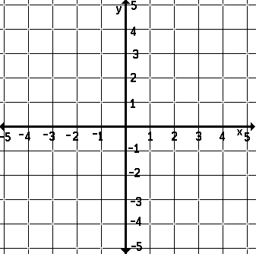
B
D

C
E
K

A

J

14) Dilate FGH by a scale 15) Horizontally shrink ABCD *16) Translate ABC 3 units right,
factor of 1.5 by a scale factor of ½ then dilate by a s. f. of 2

C
B

G

B

A
D

A
C

H
F

Directions: Find the missing point using the given information.

17) A(0, –6) 18) B’(7, –2)
Rule: (x, y) → ‘($\frac{2}{3}$ x, $\frac{2}{3}$ y) Description: Dilate by 0.2
Find A’. Find B.

19) Pre-Image: (8, 1) 20) Image: (–2, –40)
Description: Horizontal shrink by $\frac{1}{4}$ Rule: (x, y) → ‘(5x, 5y)
Find the image. Find the pre-image.

Directions: Solve each problem.

21) A triangle has vertices of M(0, 0), A(0, 15), and R(–20, 0). After a dilation, ∆MAR has two image coordinates of M’(0, 0) and R’(–50, 0). What is the ordered pair that represents A’?

22) In the rule, (x, y)$→$‘(x, 8y), what transformation has occurred?

23) Meg was given the following rule: (x, y)$→$‘‘(–5x, –5y). Meg states that the type of transformation that has occurred is a dilation by a scale factor of –5.
a) Can a negative sign be used to describe a dilation?

b) Explain the role of the negative symbol in this sequence of transformations.

24) B’’(5, 12) was produced after a horizontal shrink of $\frac{1}{2}$ and a vertical stretch of 4. What is the ordered pair that represents the pre-image, B?

