2.12 Unit 2 Test Review Geometry

Determine the converse, inverse, and contrapositive of the conditional statements. Indicate whether each statement is true or false.

1. Conditional statement: If R is the midpoint of , then . Go07an_0202read_02

Converse:

Inverse:

Contrapositive:

Write a biconditional from each given conditional and converse.

2. Conditional: If two angles share a side, then they are adjacent.

Converse: If two angles are adjacent, then they share a side.

Biconditional:

**Identify the property that justifies each statement.**

3. If ABC  DEF, then DEF  ABC. 4. 1  2 and 2  3, so 1  3.

5. 

Write a justification for each step.

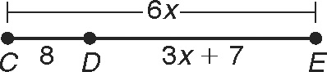

6. CE  CD  DE

6x  8  (3x  7)

6x  15  3x

3x  15

x  5

Write a justification for each step.

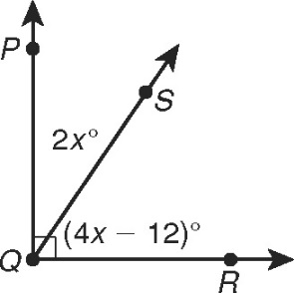7. mPQR  mPQS  mSQR

90  2x  (4x  12)

90  6x  12

102  6x

17  x

**Find each angle measure.**

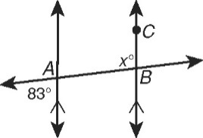 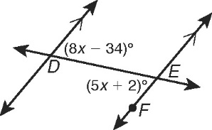

8. mABC \_\_\_\_\_\_\_\_\_\_\_\_\_\_\_\_\_\_\_\_\_\_\_ 9. mDEF \_\_\_\_\_\_\_\_\_\_\_\_\_\_\_\_\_\_\_\_\_\_\_

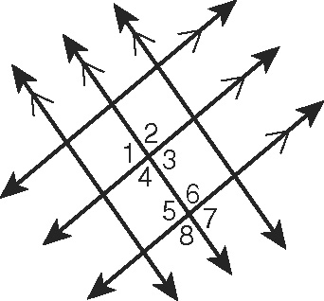Give two examples of each kind of angle pair in the figure.

10. alternate interior angles \_\_\_\_\_\_\_\_\_\_\_\_\_\_\_\_\_\_\_\_\_\_\_\_\_\_

11. alternate exterior angles \_\_\_\_\_\_\_\_\_\_\_\_\_\_\_\_\_\_\_\_\_\_\_\_\_\_

12. same-side interior angles \_\_\_\_\_\_\_\_\_\_\_\_\_\_\_\_\_\_\_\_\_\_\_\_\_

13. Corresponding angles \_\_\_\_\_\_\_\_\_\_\_\_\_\_\_\_\_\_\_\_\_\_\_\_\_

**14. Given , m∠1 = 100°, and m∠2 = 61°, find the measures of all the numbered angles.**

m∠3 = \_\_\_\_\_, m∠4 = \_\_\_\_\_\_, m∠5 = \_\_\_\_\_\_, m∠6 = \_\_\_\_\_\_

11

10

m∠7 = \_\_\_\_\_, m∠8 = \_\_\_\_\_\_, m∠9 = \_\_\_\_\_\_

12

m∠10 = \_\_\_\_\_, m∠11 = \_\_\_\_\_\_, m∠12 = \_\_\_\_\_\_

What is the relationship between ∠1 and ∠4?

What is the relationship between ∠2 and ∠8?

What is the relationship between ∠6 and ∠9?

Complete the two-column proof to show that same-side exterior angles are supplementary.

15. Given: p || q

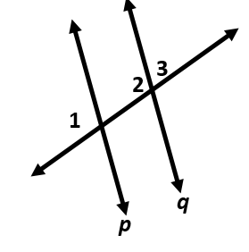 Prove: m1  m3  180

|  |  |
| --- | --- |
| **Statements** | **Reasons** |
| 1. p || q | 1. Given |
| 2. a. \_\_\_\_\_\_\_\_\_\_\_\_\_\_\_\_\_\_\_\_\_\_\_ | 2. Lin. Pair Thm. |
| 3. 1  2 | 3. b. \_\_\_\_\_\_\_\_\_\_\_\_\_\_\_\_\_\_\_\_\_\_\_ |
| 4. c. \_\_\_\_\_\_\_\_\_\_\_\_\_\_\_\_\_\_\_\_\_\_\_ | 4. Def. of  |
| 5. d. \_\_\_\_\_\_\_\_\_\_\_\_\_\_\_\_\_\_\_\_\_\_\_ | 5. e. \_\_\_\_\_\_\_\_\_\_\_\_\_\_\_\_\_\_\_\_\_\_\_ |

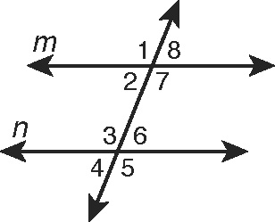

Use the figure for Exercises 16-19. Tell whether lines m and n   
must be parallel from the given information. If they are, state   
your reasoning. (Hint: The angle measures may change for   
each exercise, and the figure is for reference only.)

16. 7  3 17. m3  (15x  22)°, m1  (19x  10), x  8

18. 7  6 19. m2  (5x  3)°, m3  (8x  5), x  14

Name the shortest segment from the point to the line and write an inequality for x.

20.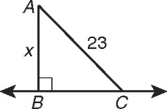 21. 