2.4 HW Making Assumptions & Basic Geometry Terms Geometry

1) Directions: Use the given figure to place each statement under the correct category.
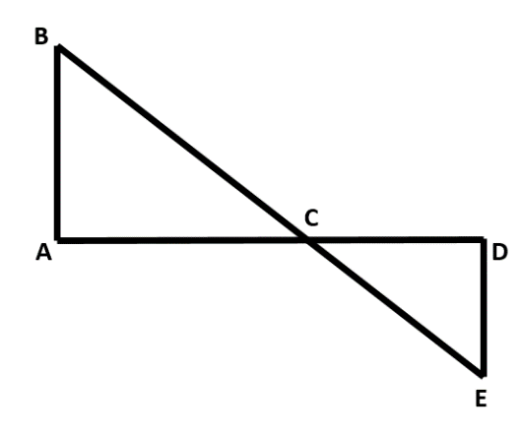

$\overset{⃡}{ACD} and \overset{⃡}{BCE }are straight lines.$ $∠B≅∠E$.
$∠BAC$ is a right angle. $∠CDE$ is an obtuse angle.
$\overline{CD}≅\overline{DE}$ E is to the right of A.
$∠$BCE is a straight angle. $\overline{BC}$ is longer than $\overline{CE}$.
C, D, & E are noncollinear. C is between B and E.

DO ASSUME DO NOT ASSUME_______

2) In the following figure, what assumptions can we make?

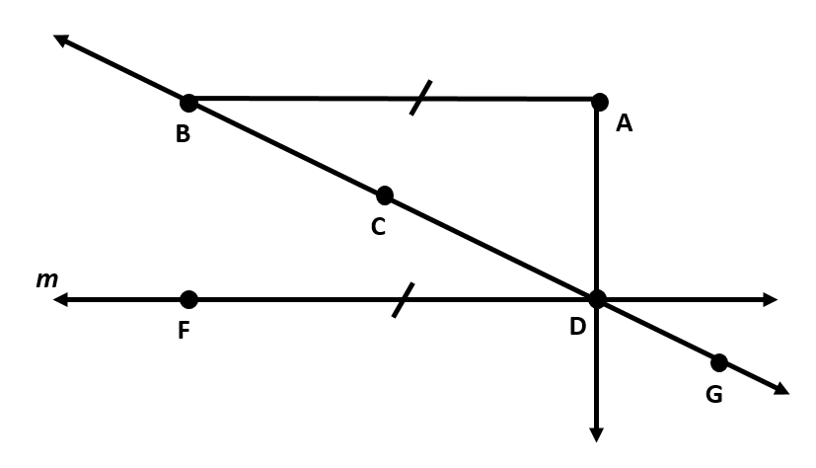
- C lies on $\overline{BD}$.

- $∠$A is a right angle.

- $\overline{AB}≅\overline{FD}$

- D lies on m.

- B, C, & G are collinear.

- $\overset{⃡}{AB}$ is parallel to $\overset{⃡}{FD}$.

- C is the midpoint of $\overline{BD}$.

- ∆ABD is a triangle.

- B lies on $\vec{GC}$.
Directions: Explain what the symbol or phrase means.

3) $\overline{AB}∥\overline{DE}$

4) JK = RW

5) A, B, & C are collinear

6) $∠J$ and $∠T$ are supplementary

7) m$∠ABC$ = 30ᴼ

8) $∠W ≅ ∠H$

9) $m∠W= m∠H$

10) $∠Q$ and $∠F$ are complementary

11) $\overset{⃡}{PJ}⊥\overline{HI}$

12) $\overline{RW}$ bisects $∠$Y

