2.5 HW Given-Statement-Reason Geometry

Directions: Complete the chart.

GIVEN | STATEMENT | REASON
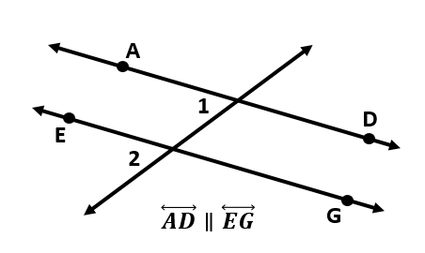

$∠L$ is supplementary to $∠M$

$$\overline{JK}≅\overline{HI}$$

m$∠$C = m$∠$H
m$∠$H = m$∠$G

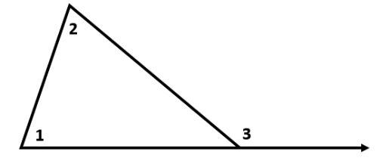

$∠$1 is complementary to $∠$2
$∠$2 is complementary to $∠$3

Point T is the midpoint of $\overline{AE}$

