2.6 Applications & Quiz Review Geometry

Directions: Match the vocabulary term to the definition or symbolic form.

_____ 1) Line a) Two angles whose sum is 90ᴼ

_____ 2) Line Segment b) $\overset{⃡}{XY}$

_____ 3) Ray c) $m∠A+m∠B=180$ᴼ

_____ 4) Straight Angle d) Two angles whose measures is the same

_____ 5) Supplementary Angles e) An angle whose measure is 180ᴼ

_____ 6) Linear Pair f) $\vec{MN}$

_____ 7) Complementary Angles g) Part of a ray or line with two endpoints

_____ 8) Congruent Angles h) Two angles whose nonadjacent sides form
opposite rays

Directions: Use the picture below to determine if you are allowed to assume each statement. Write a YES or a NO as your answer.
______ 9) Points D, E, & F are collinear
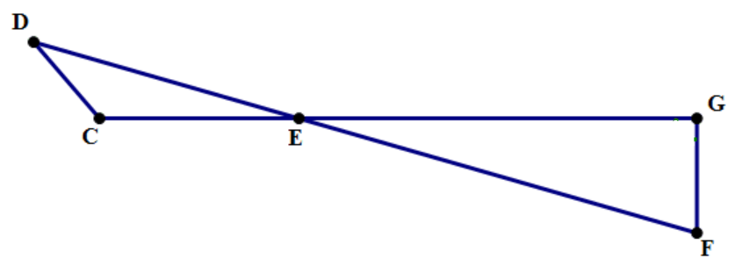
______ 10) $∠DEC ≅ ∠GEF$

______ 11) ∆GEF is a right triangle

______ 12) $E$ is between C and G

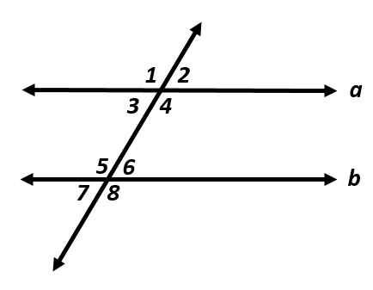
Directions: In the figure, a$∥$b. Answer each question.

13) If m$∠$1 = (2x + 25)$ᴼ$ & m$∠5$ = (3x – 37)$ᴼ$, what is m$∠3$?

14) If m$∠6$ = (6x²)$ᴼ$ and m$∠4$ = (14x²)$ᴼ$, what is m$∠4?$

15) If m$∠4$ = (–x + 60)ᴼ & m$∠5$ = (x² + x – 20)ᴼ, what is m$∠6$?

16) What is the angle relationship between $∠$1 & $∠$2? 17) What is the angle relationship between $∠$7 & $∠$2?

18) What is the angle relationship between $∠$5 & $∠$8? 19) What is the angle relationship between $∠$3 & $∠$5?

Directions: Use the conditional statement “If two segments intersect at a $90°$ angle, then the segments are perpendicular.” to find the converse, inverse, and contrapositive. Then find the truth value of each statement and write a biconditional statement if appropriate.

20) T F Converse:

21) T F Inverse:

22) T F Contrapositive:

23) Biconditional:

24) What does the triangle sum theorem state?

25) What does the alternate interior angles theorem state?

26) What does the consecutive (same-side) exterior angles theorem state?

Draw a diagram the illustrates the following statements. Be sure to include the appropriate mathematical symbols and markings (i.e. right angles have a box symbol the corner).
27) $\overset{⃡}{AC} bisects \overline{GH}$  What statement can you make about your diagram using the definition of segment bisector? | 28) $∠ABC and ∠CBX$  $$form a linear pair$$  What statement can you make about your diagram using the definition of linear pair? | 29) $A is the$  $$midpoint of \overline{MN}$$  What statement can you make about your diagram using the definition of midpoint? | 30) $n∥m and are cut$  $$by a transversal$$  *label the angles you just created with numbers 1-8  What statement can you make about your diagram using corresponding angles theorem?

