3.12 Unit 3 Test Review
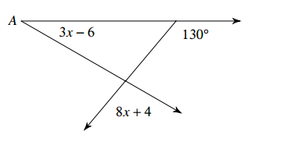
Directions: Solve for x. Then find the missing angle.
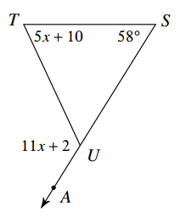
1) 2)
x = ___________ x = ________
m$∠$TUA = ______ m$∠$A = _____

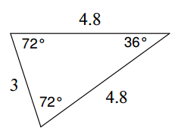
Directions: Classify the triangle by its angles. Direction: Classify the triangle by its sides.
3) m$∠$A = (4x + 10)ᴼ 4)
m$∠$B = (–3x + 60)ᴼ
m$∠$C = (x + 74)ᴼ

Directions: Determine if the triangles are congruent. If they are, justify your answer & write a triangle congruence statement.
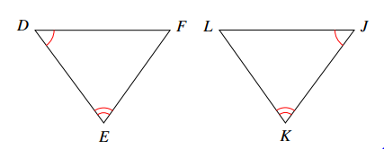
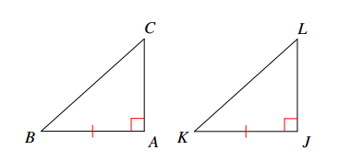
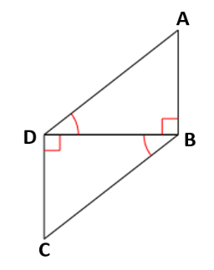
5) 6) 7)

Directions: Determine the missing information needed to prove the triangles are congruent with the given theorem or postulate.
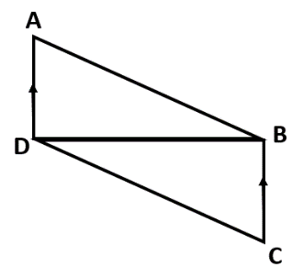
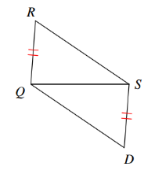
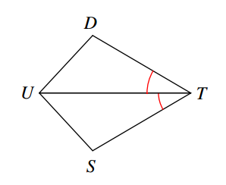
8) ASA 9) SSS 10) AAS

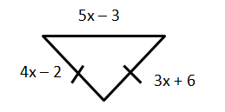
11) Given that ∆CDE $≅$ ∆HIJ, CE = 5x, 12) What is the length of the longest side?
and HJ = 2x + 15, find x and CE.

13) What is the measure of the vertex angle in an 14) In an isosceles triangle, a vertex angle measures 3x
isosceles triangle if a base angle measures 45°? and a base angle measures x. What is the measure
of each of the angles in the isosceles triangle?

Directions: Determine if the following side lengths can be used to make a triangle. If they are, write the sides in order from least to greatest and then the angles in order from least to greatest.
15) AB = 5, BC = 8, AC = 10 16) MN = 3, LN = 2, ML = 5

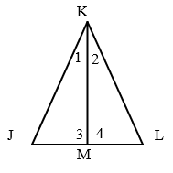
17) Given: $∠1≅$ $∠2$ 18) Copy the segment and angle onto another piece
$∠3≅$ $∠4$ of paper. Then, bisect the segment and angle.
Prove: ∆JKL is isosceles
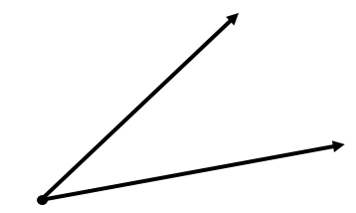

Directions: Use the triangle midsegment theorem and the figure below to answer 19 – 22.
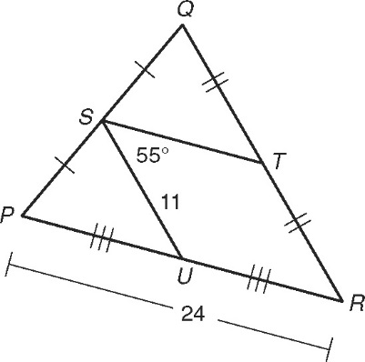

19) ST _____________________ 20) QR _____________________

21) PU _____________________ 22) m$∠$SUP _____________________

