3.1 Constructions: Copy & Bisect Segments & Angles Geometry

Directions: Complete each construction using a compass and a straightedge only.

1) Copy the line segment. 2) Copy the line segment.

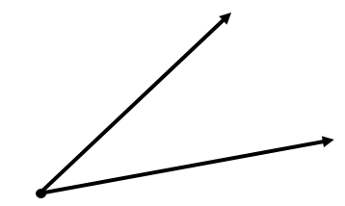
3) Copy the angle. 4) Copy the angle.
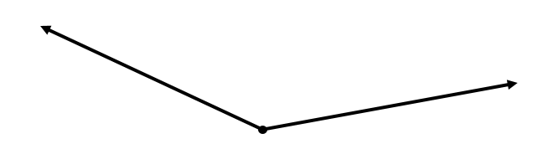

5) Bisect the line segment. 6) Bisect the line segment.

7) Bisect the angle. 8) Bisect the angle.

3.1 Constructions Applied: Copy & Bisect Segments & Angles Geometry

Directions: Complete each construction using a compass and a straightedge only.
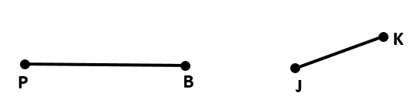
1) Use Segment Addition Postulate to combine the segments.

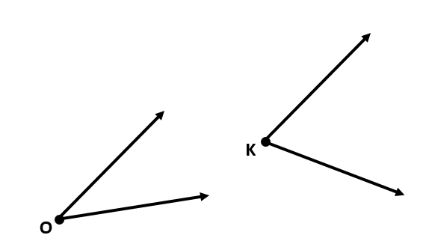

2) Use Angle Addition Postulate to combine the angles.

3) Copy the triangle. (Hint, copy $\overline{AB}$ first. Then, copy $∠$A. Then, copy either $\overline{AC}$ or $∠$B.)

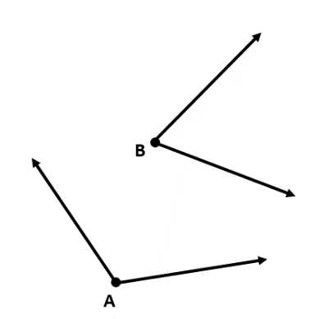

4) Complete the construction: $\frac{1}{2}*m∠A+m∠B$

5) Complete the construction: $\frac{1}{4}ME$

Directions: Describe the next step in completing the construction.

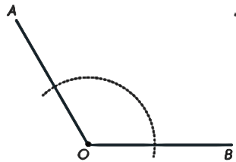
6) Construction: Copy the angle. 7) Construction: Bisect the angle.
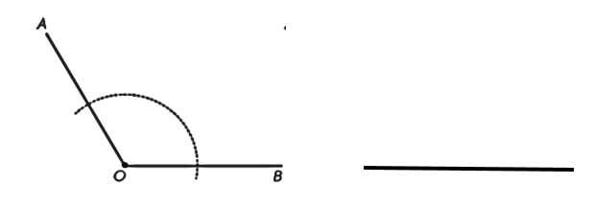

8) Construction: Bisect a segment. 9) Construction: Copy a segment.
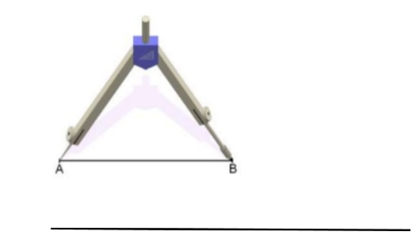

Directions: Complete the construction.

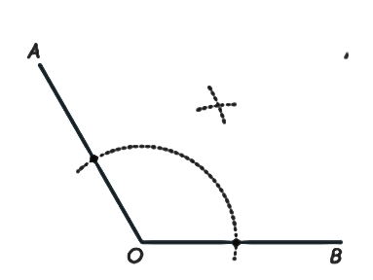
10) Bisect a segment. 11) Bisect the angle.
