3.3 HW Introduction to Triangles Part I Geometry

Directions: Match the triangle description with the most specific name.
1) Side lengths: 2 cm, 3 cm, 4 cm A. Equilateral

2) Angle measures: 60ᴼ, 60ᴼ, 60ᴼ B. Obtuse

3) Side lengths: 3 cm, 2 cm, 3 cm C. Equiangular

4) Angle measures: 30ᴼ, 60ᴼ, 90ᴼ D. Scalene

5) Side lengths: 4 cm, 4 cm, 4 cm E. Isosceles

6) Angle measures: 20ᴼ, 145ᴼ, 15ᴼ F. Right

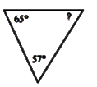
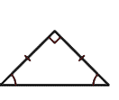
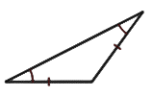
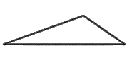
Directions: Classify the triangle by its angles and by its sides.
7) 8) 9) 10)

Directions: Complete the statement using always, sometimes, or never.

11) An obtuse triangle is ________________________ an isosceles triangle.

12) An interior angle of a triangle and one of its adjacent exterior angles are ______________________ supplementary.

13) A triangle ___________________ has a right angle and an obtuse angle.

14 An isosceles triangle is _____________________ an equilateral triangle.

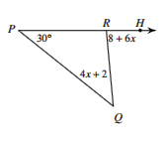
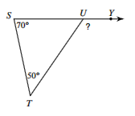
Directions: Solve for x and find the measure of the exterior angle shown.
15) 16)

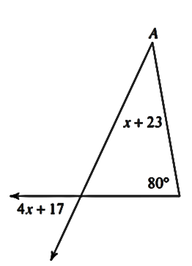
Directions: Solve for x and find the measure of the exterior angle shown.
?
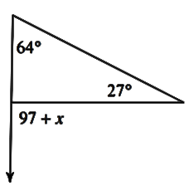
17) 18)

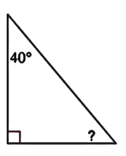
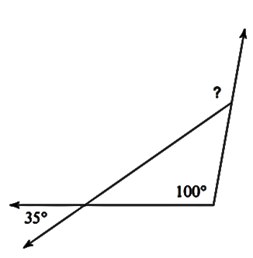
Directions: Find the missing angle measure.
19) 20)

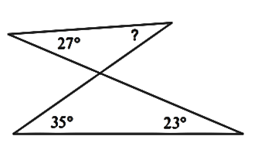
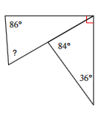
21) 22)

