4.3 HW Congruent Versus Similar Triangles Geometry

Directions: Find the information given each set of figures.

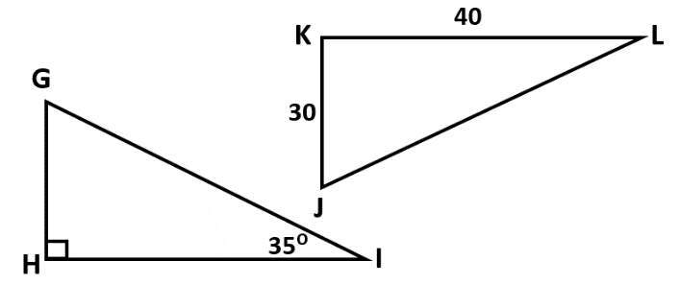
1) ∆ABC ~ ∆DEF 2) ∆GHI $≅$ ∆JKL
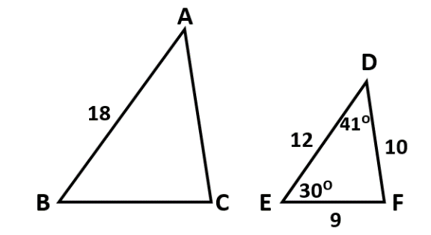

a) What is m$∠$A? ____________ a) What is m$∠$K? ______________

b) What is AC? ____________ b) What is JL? _____________

c) What is m$∠$C? ___________ c) What is GI? _____________

d) What is BC? _____________ d) What is m$∠$J? ______________

Directions: Use the given information to complete each statement.
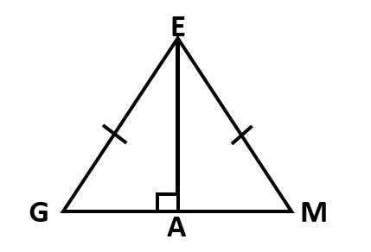
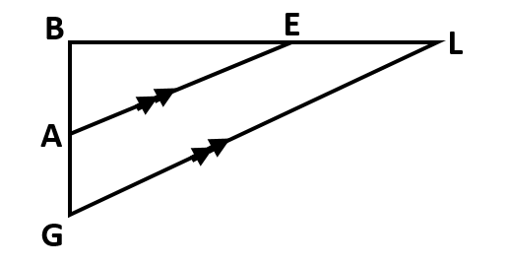
3) 4)

a) ∆AGE $≅$ ∆_________ by _________ a) ∆ABE ~ ∆_________ by _________

b) $∠$EGA $≅$ $∠$ _______ because of ___________ b) $\frac{BE}{?}=\frac{AE}{GL}$ so ? represents this segment _____

Directions: Determine whether there is enough information to prove whether the triangles are similar or congruent. If so, state the theorem or postulate that can be used to prove they are congruent. If not, write neither.
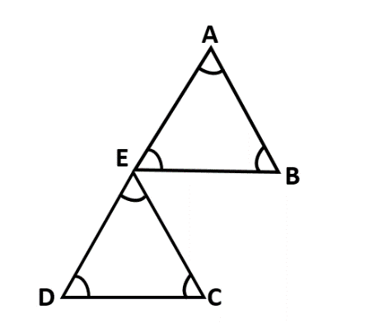
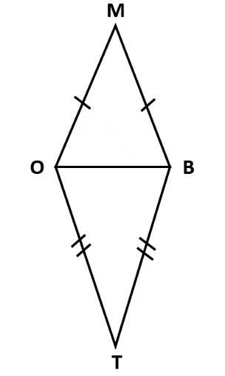
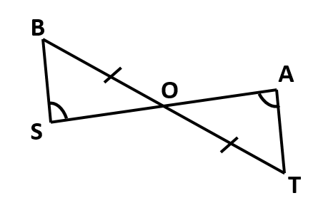
5) 6) 7)

8) Given: RA is an altitude
$∠$RYA $≅$ $∠$RNA
Prove: ∆RYA $≅$ ∆RNA
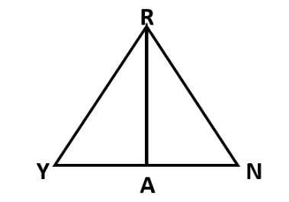

9) Given: $∠SGK$ $≅$ $∠TBK$
∆SKT is isosceles with $∠SKT$as the vertex angle
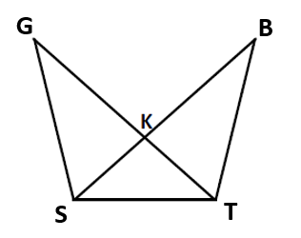
Prove: ∆SGT ~ ∆TBS

10) Given: AV = EV
$\overline{DV}$ bisects $∠$AVE
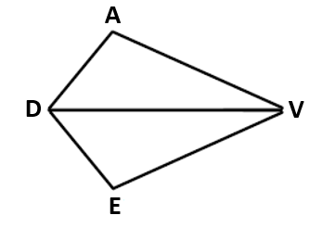
Prove: DE = AD

