5.7 Unit 5 Test Review
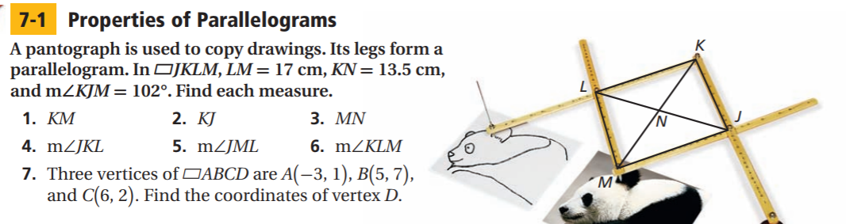

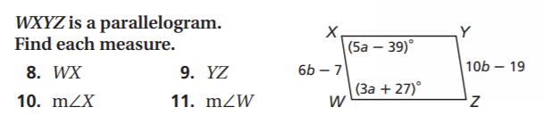

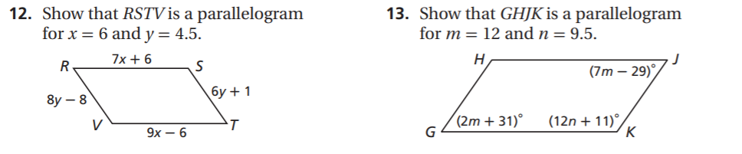

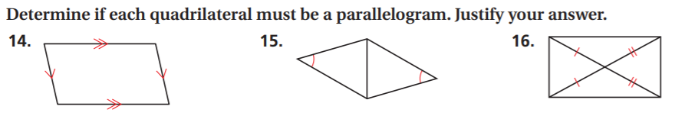

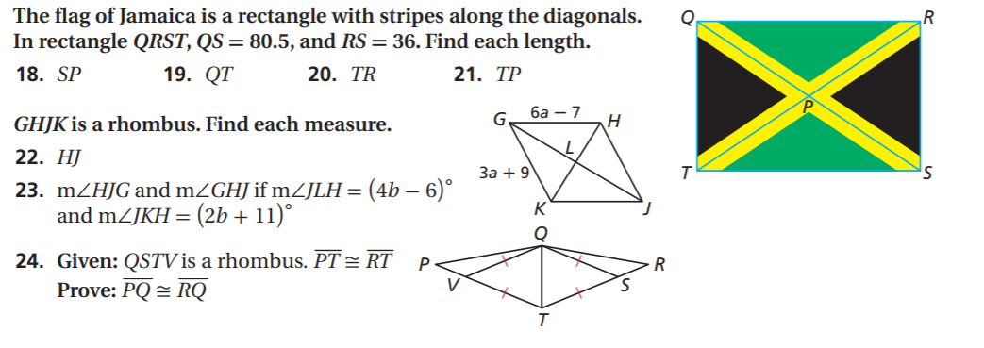
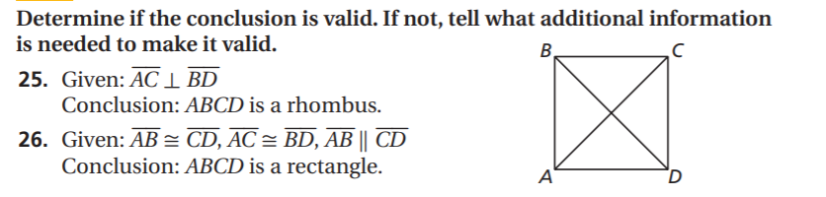

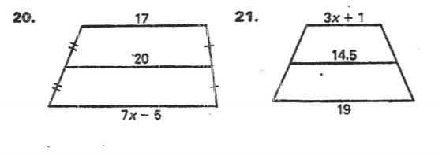
Find the value of x: Find the measure of angle K:
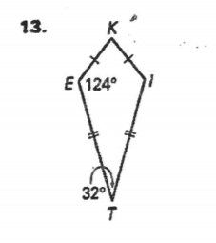

Use the Pythagorean Theorem to find the side lengths of the kite:
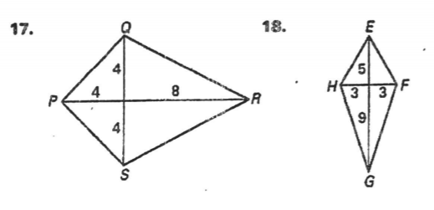
Find the measure of angle A, B, &C:
