6. 13 Unit 6 Quiz II Review Name: ____________________

1. Write cos (28) in terms of its cofunction.

2. If sin (2x + 10) = cos (x – 30), then what is the value of x?

3. A helicopter flying 3,590 feet above ground spots the top of a 150-foot tall cell phone tower at an angle of depression of 77°. How far must the helicopter fly to be directly over the tower?

4. The angle of depression from a bird sitting on top of a telephone pole to the base of a tree is 63°. If the telephone pole is 18 feet tall, what is the distance between the pole and the tree?

5. The angle of elevation from a park bench 778 feet from the base of the Gateway Arch in St. Louis, Missouri is 39°. How tall is the Gateway Arch?

6. Elijah is 6 feet tall and looking up to the top of the Washington Monument. If the monument is 555 feet tall and the angle of elevation from Elijah to the top is 74°, how far is he standing from the base of the monument?

7. Malaya is standing directly between a 90-foot tall courthouse and a 54-foot tall bank. If the angle of elevation from the point where Malaya is standing to the top of the court house is 72°, while the angle of elevation to the top of the bank is 35°. What is the distance between the courthouse and the bank?

8. The town park does an outdoor movie night every Saturday during the summer on a large screen. Kate is sitting 36 feet from the base of the screen, watching a movie with her family. If the angle of elevation from Kate to the top of the screen is 24°, how tall is the movie screen?

9 A cell phone tower is anchored by two cables on each side for support. The cables stretch from the top of the tower to the ground, with each being equidistant from the base of the tower. The angle of depression from the top of the tower to the point in which the cable reaches the ground is 23°. If the tower is 140 feet tall, find the ground distance between the cables.

10. Max built a skateboarding ramp that is 16 inches high. The angle formed by the ramp and the ground is 21°. What is the length of the ramp?

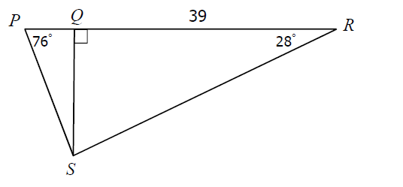
11. Find PS

