6.6 HW Missing Parts of Right Triangles Geometry

Directions: Find the values of x and y.
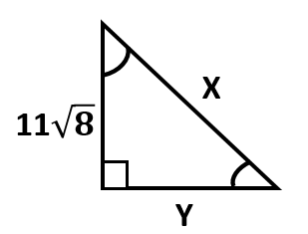
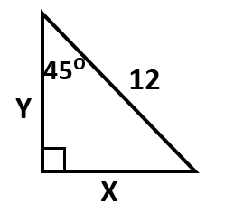
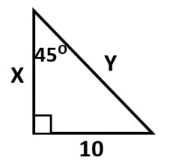
30ᴼ
1) 2) 3) 4)

Directions: Find each missing side & angle. Round each side to the nearest tenth & each angle to the nearest degree.
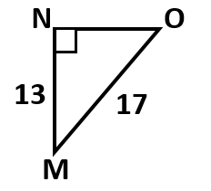
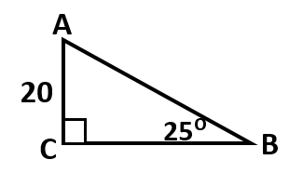
4) 5)

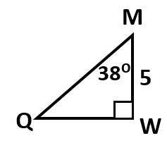
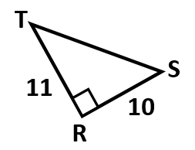
6) 7)

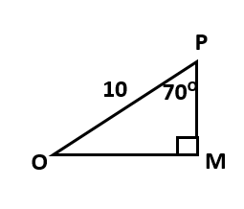
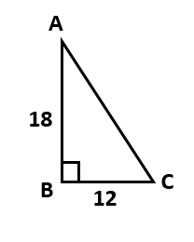

8) 9)

Directions: Sketch the figure and then find the missing parts.

10) Points F, G, & H are the vertices of a triangle. F is a right angle. GH = 12 and FG = 4.

11) Points M, A, and P are the vertices of a right triangle. MA is the hypotenuse, and it is 15 units long. Angle A is 27ᴼ.

12) Points R, E, and M are points on a right triangle. The legs RE and EM both measure 18 units.

13) In a right triangle, there are two congruent angles. The hypotenuse measures 20 units. Y and X are complementary angles.

Draw a picture and answer each question:
Given: ∆ABC is an isosceles right triangle; m$∠$B = 90ᴼ; $\overline{BD}$ bisects $∠$ABC; BD = 10

14) What is BC? 15) What is AB?

16) What is DC? 17) What is the perimeter of ∆ABC?

