6.7 HW Sine/Cosine Relationships Name: _________________________________
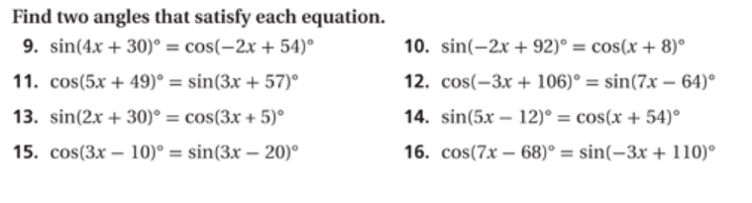
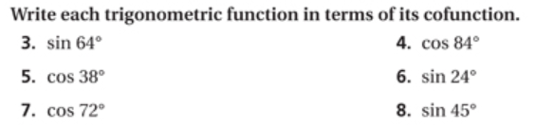
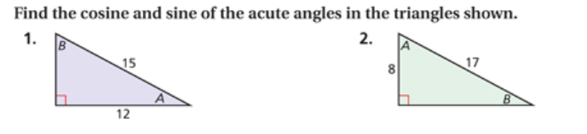
Date: ________ Period: _________

