Name _________________________________________________________ 8.12 Unit 8 Test Review

**Directions: Find the volume of each shape with the given information.**

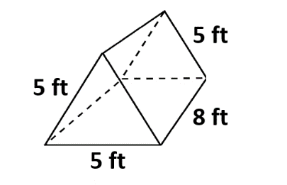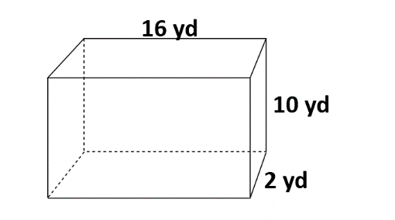

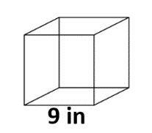1) 2) 3) Cube

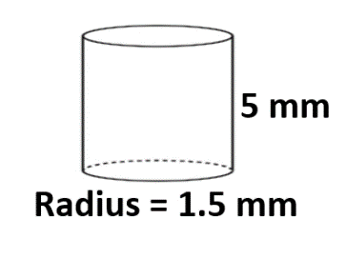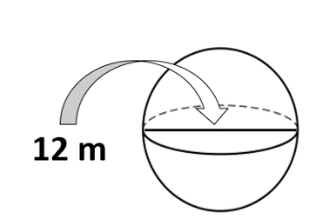

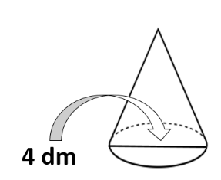4) 5) The height is double 6) the radius.

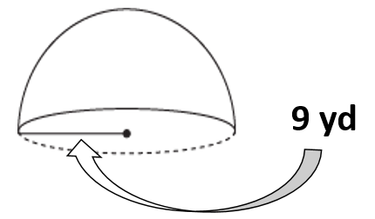

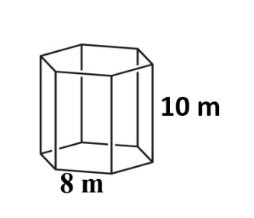7) Regular (square) Pyramid 8) Regular Prism 9)

with base edges of 24 ft &

height of 13 ft.

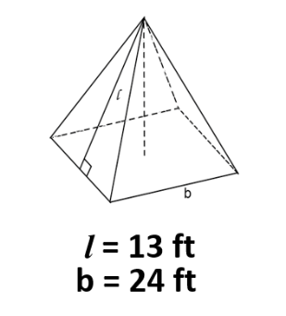

10) The volume of a ball is 972 cm3. What is the radius of this ball to the nearest tenth?

11) The circumference of the Earth is estimated to be about 7920 $π$ miles. What is the estimated volume of the Earth?

**Directions: Find the volume for each composite figure.**

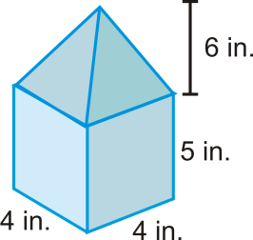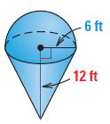12) 13)

13) A regular pentagonal (5 sides) prism has an apothem of 3 inches and a height of 5 inches. What is the volume of the pentagonal prism?

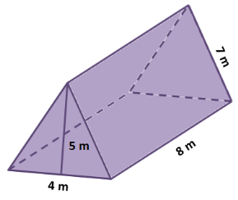

**12 ft**

**23 ft**

**12 ft**

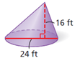14) Find the volume of each figure.

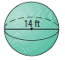

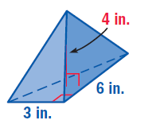

**ft**

**ft**

**ft**

**2**

**2**

**1**

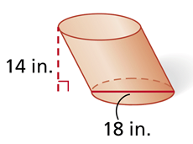







**ft**

**2**

**ft**

**ft**

15) Find the area of the vertical cross section of a cone whose radius is 8 and height is 10.

16) A cube has an edge length of 6.5 in. If the dimensions of the cube are multiplied by $\frac{1}{4}$ describe the effect on the volume.

17) The volume of a cylinder is 490 $π$ ${cm}^{3}$. The radius of the cylinder is 7. What is the height of the cylinder?