9.10 HW Writing Equations of Circles Name: ______________________________

Review: Write the equation of the circle in STANDARD form.

1) $x^{2}+2x+y^{2}-10y+10=0$ 2) $x^{2}+y^{2}-4x+6y+9=0$

Directions: Write the equation of the circle in GENERAL form.
3) ${\left(x-2\right)}^{2}+{\left(y+6\right)}^{2}=25$ 4) ${\left(x+5\right)}^{2}+y^{2}=27$

5) $x^{2}+{\left(y-3\right)}^{2}=14$ 6) ${\left(x+1\right)}^{2}+{\left(y-7\right)}^{2}=39$

Directions: Write the equation of the circle in both forms.
7) Center: (2, –3) & Radius: 7 8) Center: (–13, –16) & Point on the Circle:
( –10, –16)

9) Center: (0, 5) & Diameter: 10 10) Center: (4, 1) & Point on the Circle: (4, 4)

11) Ends of the diameter are (18, –13) and (4, –3) 12) Center: (0, 13) & Area of 25$π$

13) Ends of Diameter are (0, 0) & (0, 6) 14) Center: (3, 1) & Circumference of 10$π$

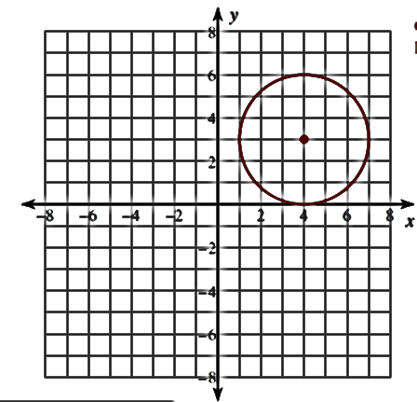
15) 16) Center (1, –4) & Tangent to x = 5
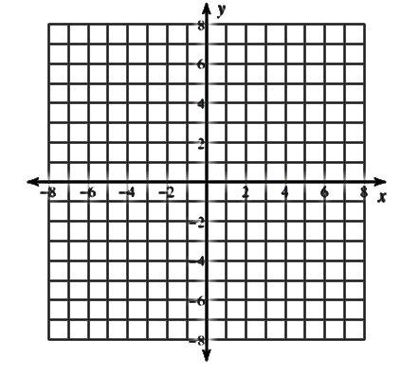

17) Center: (0, 0) & Tangent to y = –3 18) Inscribed in the system of
y = 3, y = 7, x = 1, & x = 5

