9.1 HW Parallel Lines and Perpendicular Lines on a Coordinate Plane Geometry

Directions: Find the slope of each line.
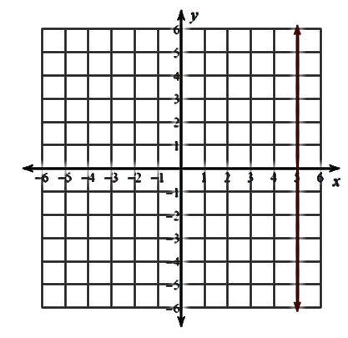
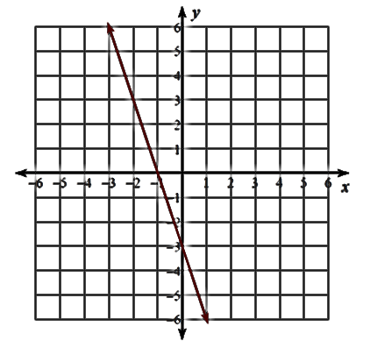
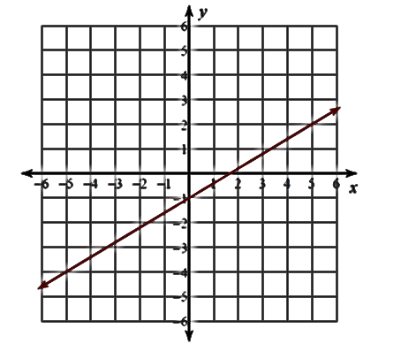
1) 2) 3)

Directions: Find the slope of the line that passes through the two points.

4) (5, 8) & (–4, 1) 5) (6, –3) & (–1, –3) 6) (–2, 5) & (6, –11)

Directions: Identify the slope that would create a line that is parallel to the given line.

7) y = 3x – 4 8) y = $-\frac{5}{4}$ x + 1 9) y = 5

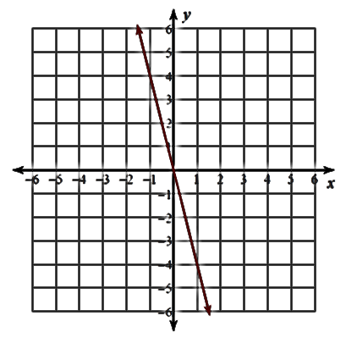
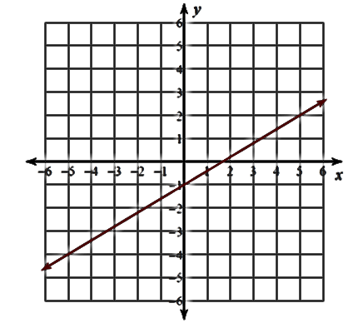
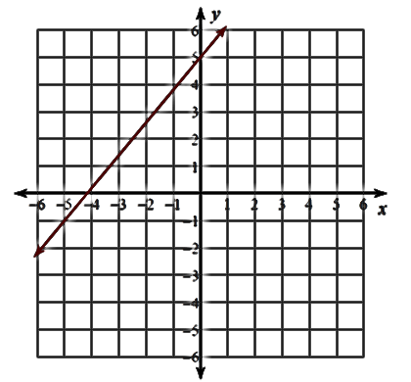
10) 11) 12)

Directions: Identify the slope that would create a line that is perpendicular to the given line.

13) y = 3x – 4 14) y = $-\frac{5}{4}$ x + 1 15) y = 5

16) 17) 18)

Directions: Graph the line that is parallel or perpendicular to the given line and passes through the given point.

19) $∥$ & passes through (0, –5) 20) $⊥$ & passes through (0, 2) 21) $∥$ & passes through (2, 3)
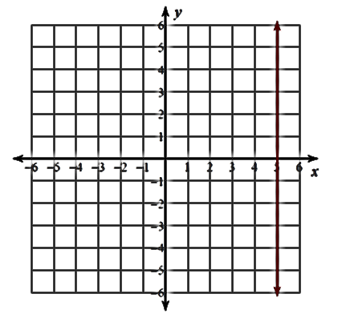
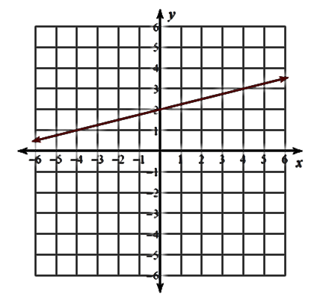
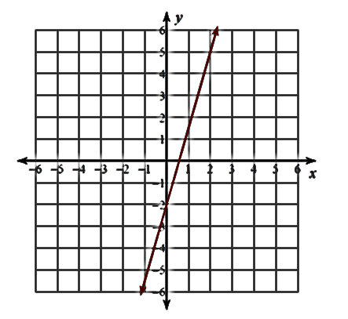

Directions: State the slope(s) needed to complete each specified shape. Then, complete the shape.

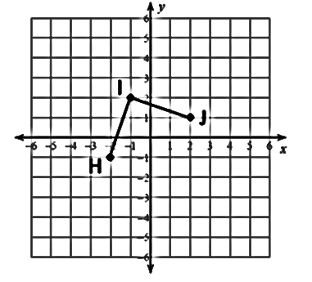
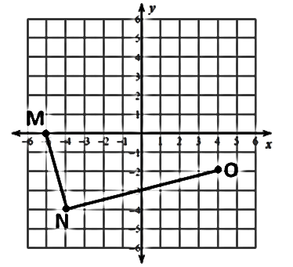
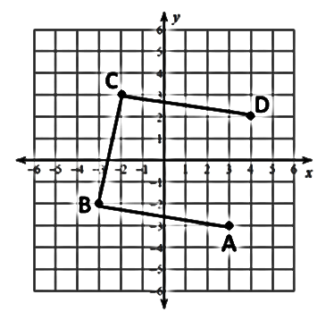
22) Rectangle MNOP 23) Parallelogram ABCD 24) Rhombus HIJK

