9.3 HW Midpoint Formula, Partitioning a Segment, & Coordinate Plane Review Geometry

Directions: Identify if the set of lines are parallel, perpendicular, coincidental, or neither.

1) $\left\{\begin{aligned}y=-2x+3 \\ y=-2x-5\end{aligned}\right.$ 2) $\left\{\begin{aligned}2y-8x=-10 \\ y=4x-5\end{aligned}\right.$ 3) $\left\{\begin{aligned}y=4x-3 \\ -4x-y=-3\end{aligned}\right.$ 4) $\left\{\begin{aligned}y=0.25x \\ y=-4x-5\end{aligned}\right.$

Directions: Write the equation of the line with the following characteristics.

5) Is parallel to the equation y = 4x – 2 6) Is coincidental to the equation y = 5x

7) Is perpendicular to the equation y = 2x – 4 8) Is parallel to y = 4x – 2 & has a y-int. of 3

9) Is perpendicular to y = -0.25x – 2 and passes 10) Is parallel to 2x – 4y = 8 and passes through
through the point (3, 4) the point (0, 6)

Directions: Find each equation that:

11) …is parallel to the given line and passes 12) …is perpendicular to the given line and
through the given point. passes through the given point.
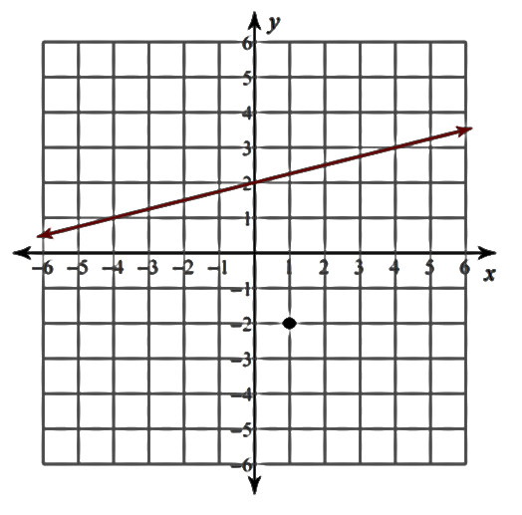
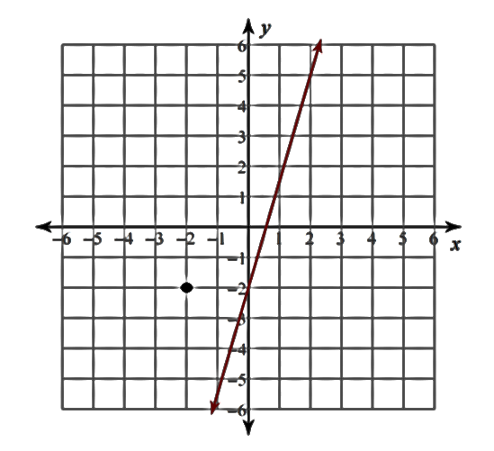

Directions: Find the equation of the line that can be used to finish creating the listed quadrilateral.

13) Parallelogram 14) Rhombus
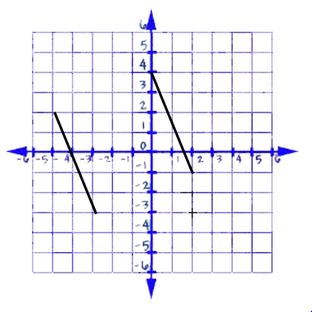
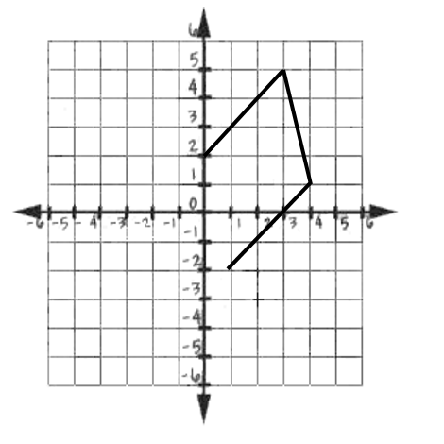

Directions: Partition each segment by the given ratio.

15) (1, 3) & (8,4); 4:1 16) (-2, 1) & (4, 5); 3:7 17) (8,0) & (3, -2); 1:4

18) (1.5, 6) & (1.5, -2); 3:5 19) (-14, 3) & (10, -4); 1:2 20) (4, 7) & (8, 7); 2:2

Directions: Find the midpoint of each segment.
21) A(3, 5) & B(-2, 6) 22) C(0, 4) & D(5, -2) 23) E(-2, -4) & F(-8, 2)

Directions: Find the missing endpoint if the midpoint is (3, 6).
24) A(5, 11) 25) A(0, -4)

