9.5 HW Area & Perimeter on the Coordinate Plane Name: ______________________________

Directions: Find the perimeter and area for each figure.
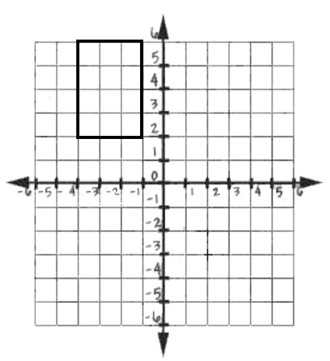
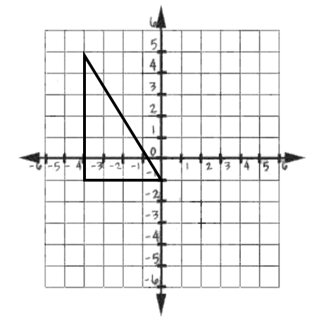
1) 2)

Perimeter: _______________ Perimeter: ________________

Area: _________________ Area: ______________

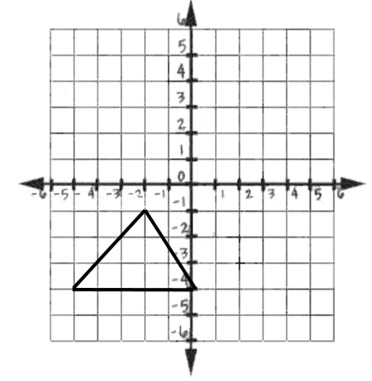
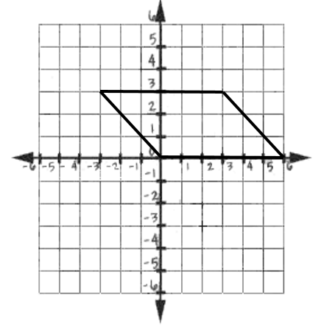
3) 4)

Perimeter: _______________ Perimeter: ________________

Area: _________________ Area: ______________
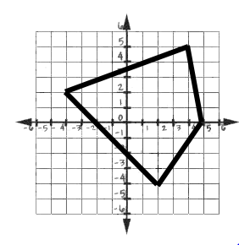
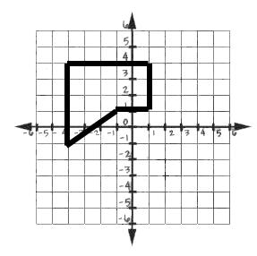
5) 6)

Perimeter: _______________ Perimeter: ________________

Area: _________________ Area: ______________

Directions: Find the perimeter and area for each figure.
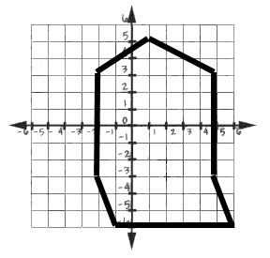
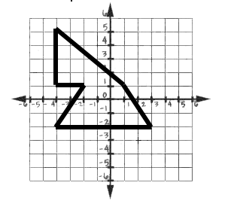
7) 8)

Perimeter: _______________ Perimeter: ________________

Area: _________________ Area: ______________

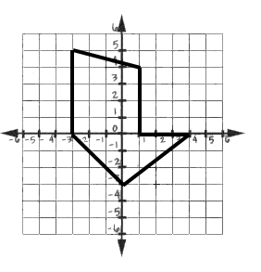
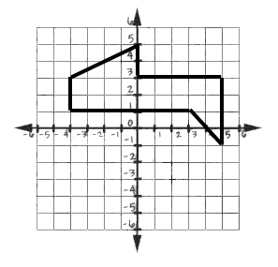
Directions: Determine which shape has the larger perimeter. Justify your answer.

9)

Directions: Determine which shape has the larger area. Justify your answer.
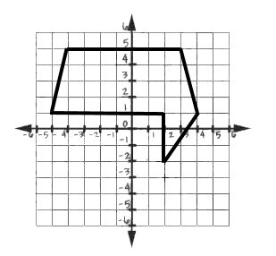
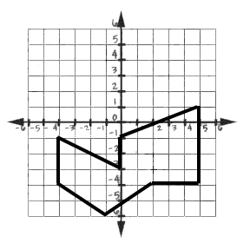
10)

