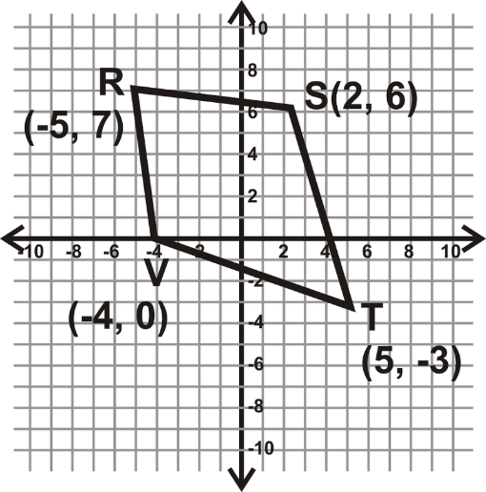
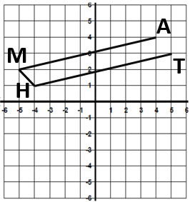
9.6 Unit 9 Quiz 1 Review Name: ________________________________
1. What is the slope of the line y = -3x + 1? ______ What is the slope of a line parallel to this line? _____
What is the slope of the line perpendicular to this line? ___________
2. What is the slope of the line perpendicular to y = $\frac{2}{3}$ x + 8?
3. Provide an equation for a perpendicular to the line y = $\frac{4}{5}$ x + 4.
4. Write the equation for the line that passes through points (2, 5) & (-2, 4).
5. Write the equation of a line that is parallel to the line y = 3x – 3.
6. Write the equation of the line that is parallel to y = x -1 and passes through the point (2, 6).
7. Write the equation of a line that is perpendicular to the line y = 8x + 7.
8. What is the slope of the line that passes through points (8, 0) & (-2, 4)? Write the equation of the line.
9. What is the distance between (3, -3) & (7, 2)? Write the equation of the line that passes through these points.
10. What is the perimeter of a triangle with vertices (-1, 3), (0, 4), & (0, 3)?
11. Find the perimeter of quadrilateral RSTV.
12. Find the area of quadrilateral RSTV.
13. Find the midpoint of the segment with endpoints at (1, 4) & (4, 6).
14. Partition the segment with endpoints at (-2, 3) & (10, 6) at a ratio of 1:2.
15. Partition the segment with endpoints (12, 12) & (-3, 2) at a ratio of 1:4.
16. Write the equation of the line that would complete the
parallelogram MATH. Then, find its perimeter and area.
17. Are the lines that pass through (3, -1) & (4, 2) and (1, 1) & (-3, 4)
parallel, perpendicular, coincidental, or none?

