9. 7 HW Graphing Circles Name: ________________________

Directions: Find the equation of the circle.

1) Equation: _____________________ 2) Equation: _________________________
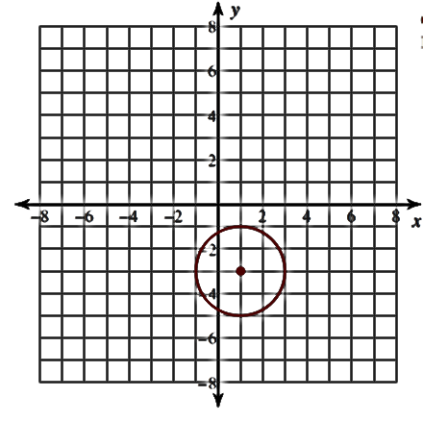
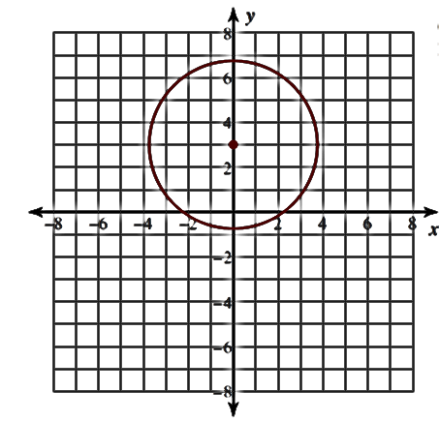

3) Equation: _____________________ 4) Equation: ________________________
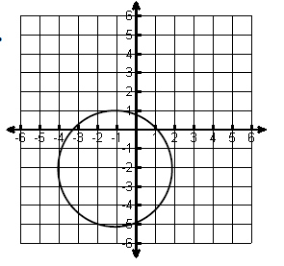
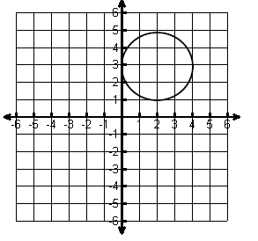

Directions: Write the equation given the following information.

5) Center (3, 5) and a radius of 8 6) Center (1, –2) and a diameter of 22

7) Center (–6, 0) and a diameter of $\sqrt{8}$ 8) Center (3, –3) and a radius of 7

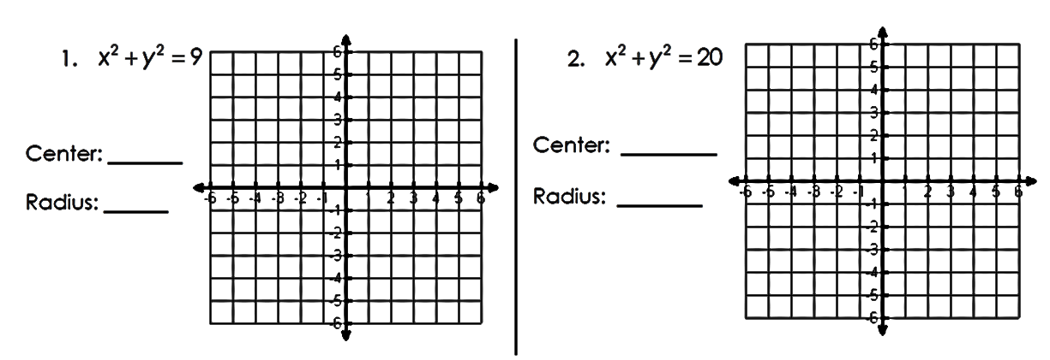
Directions: Graph the following circles. State the radius and center.

9) 10)

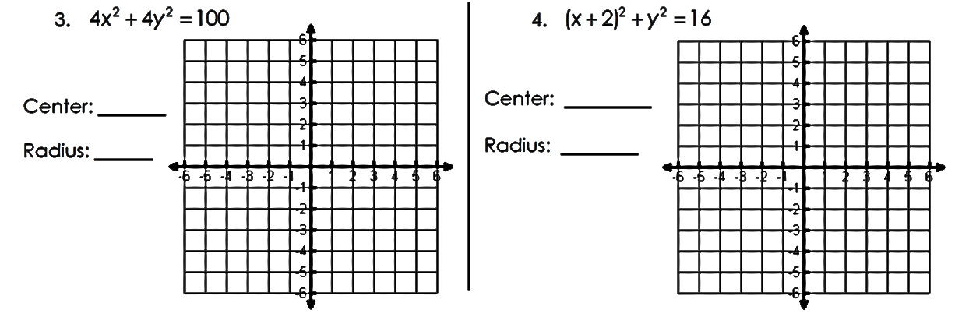
11) 12)

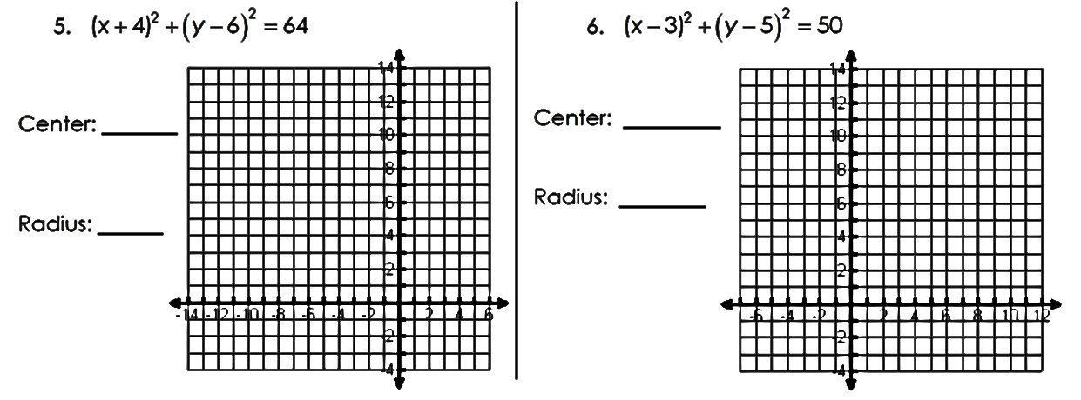
13) 14)

